CLOUD LAB ASSIGNMENT 5 & 6

E22CSEU0550

RASHMIKA KASHYAP

Using lambda integration instead of mock

Creating a lambda function to interact with Api gateway and show temperature 74

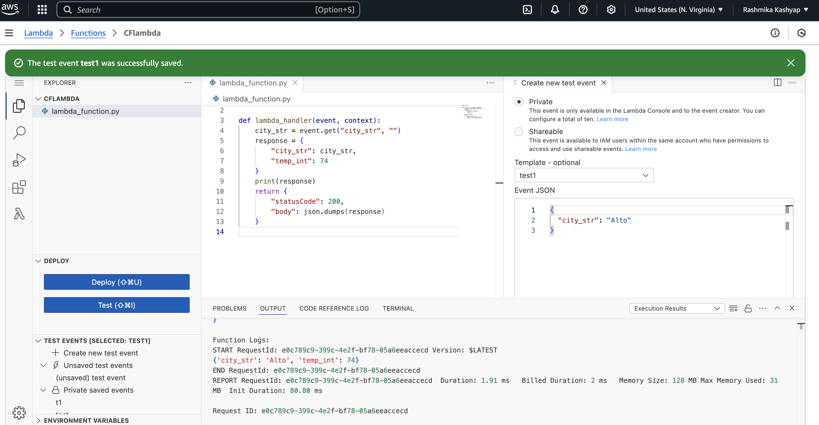

Testing the API integration response

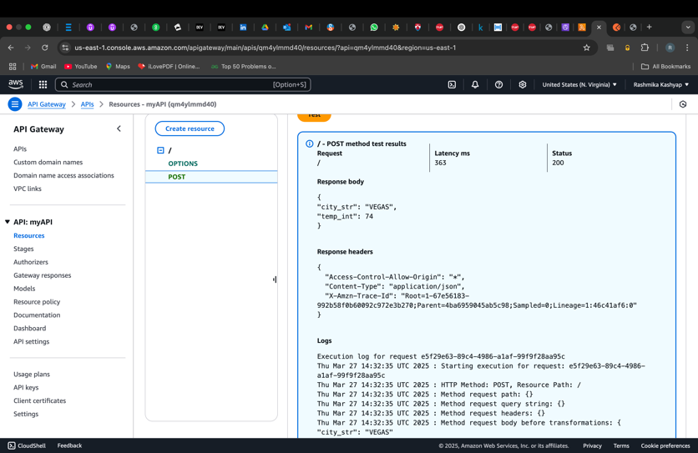

Changing the .config file with the invoke URL from the stage used



Enabling CORS and deploying the API

Deploying the API and testing on postman

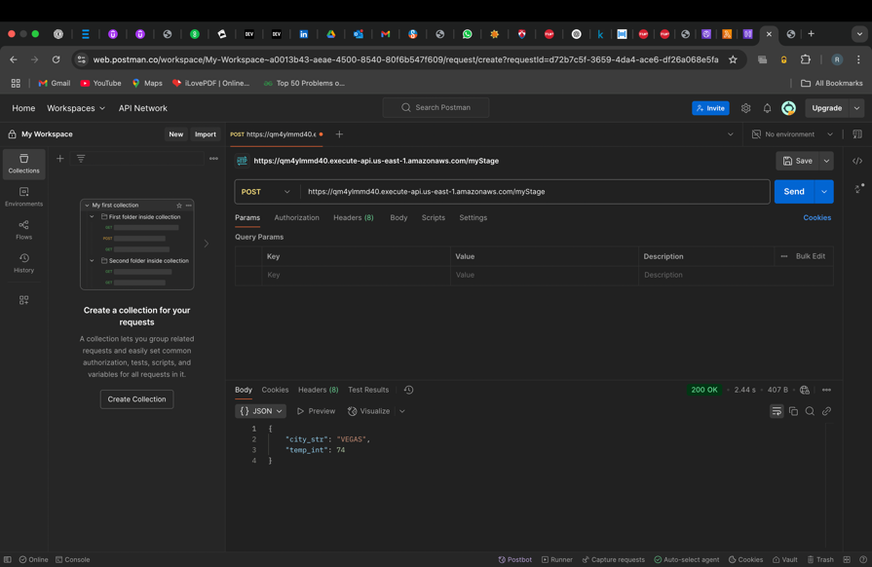

Temperature as 74 for all cities

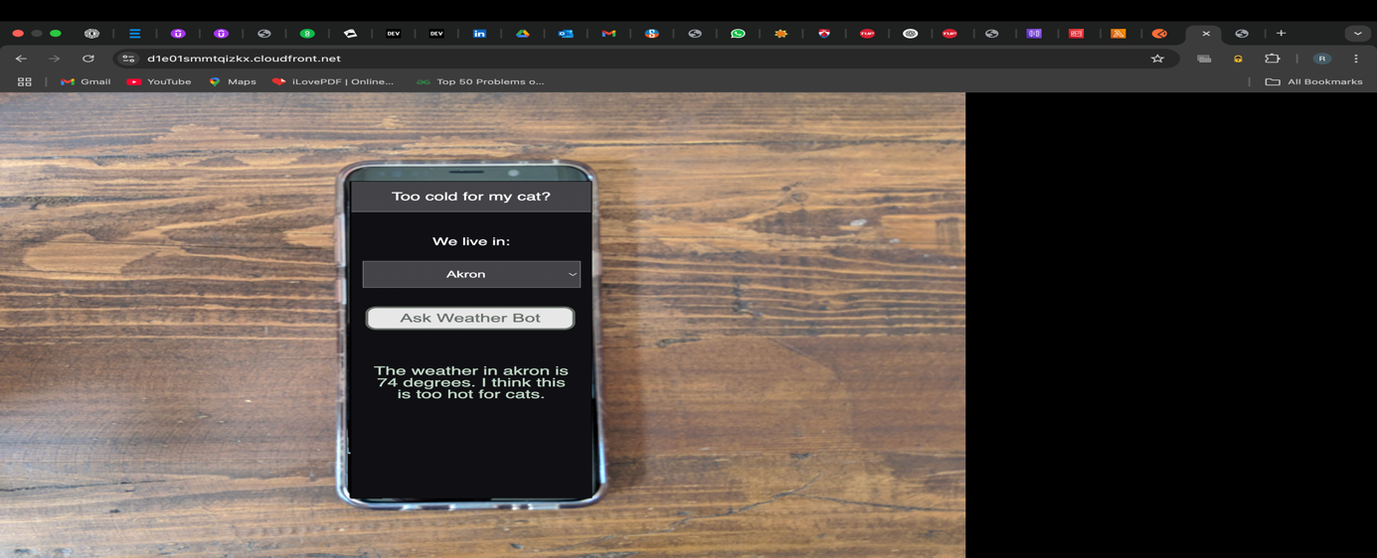

Creating dynamo db table

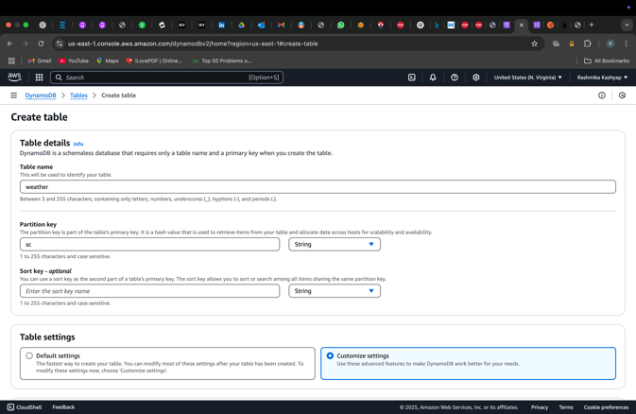

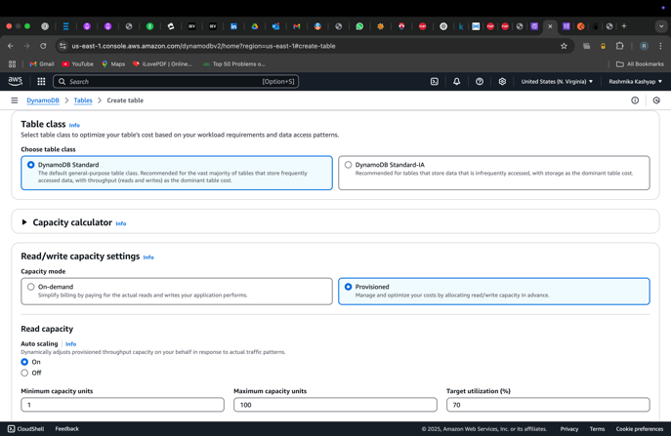

Creating seedDynamo lambda function that reads from cities.csv and populates the dynamo db table

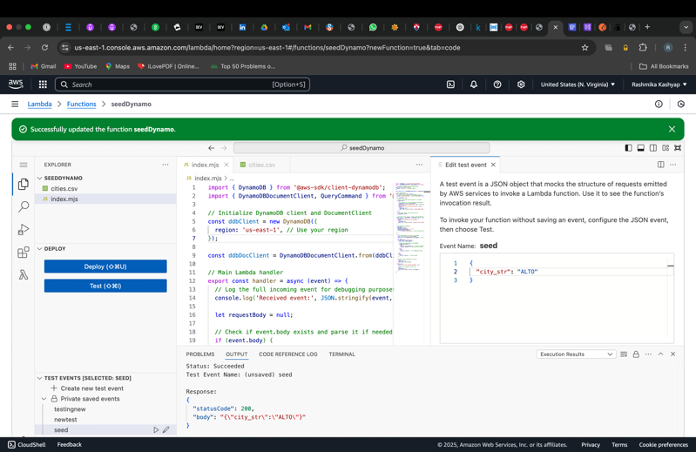

Scanning and querying dynamo db table for the cities

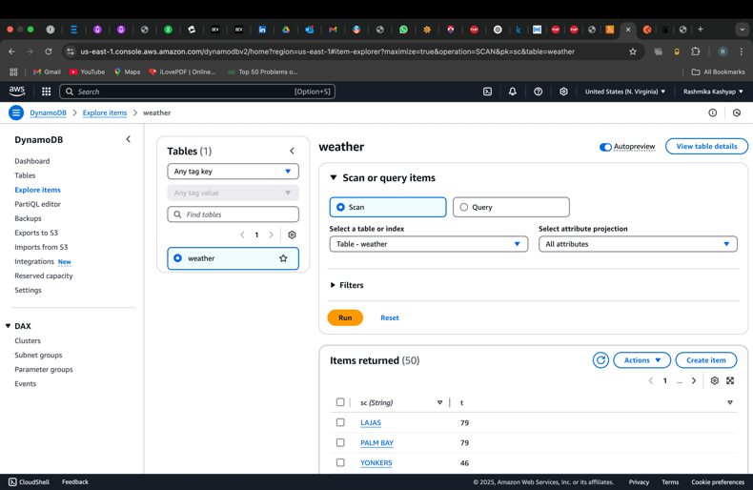

Updating the previous lambda function to fetch temperature of cities from dynamo db

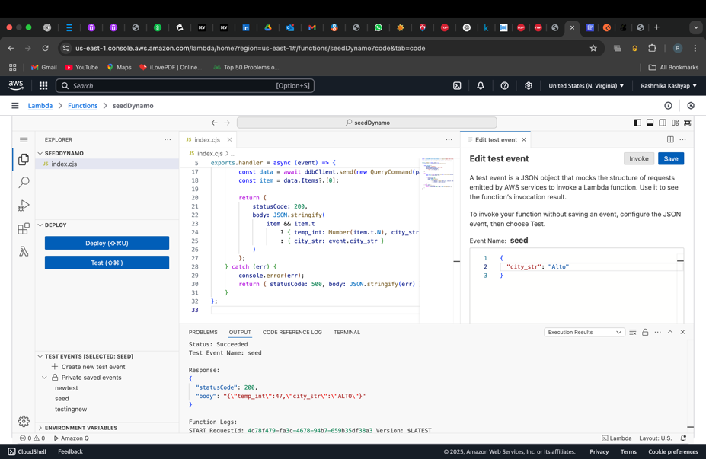

Enabling CORS and deploying the API

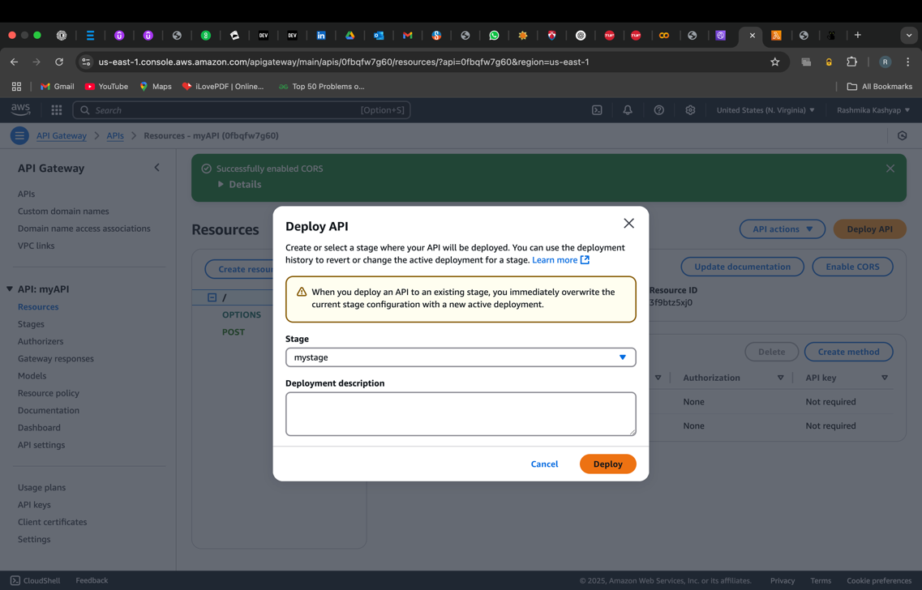

Testing on postman

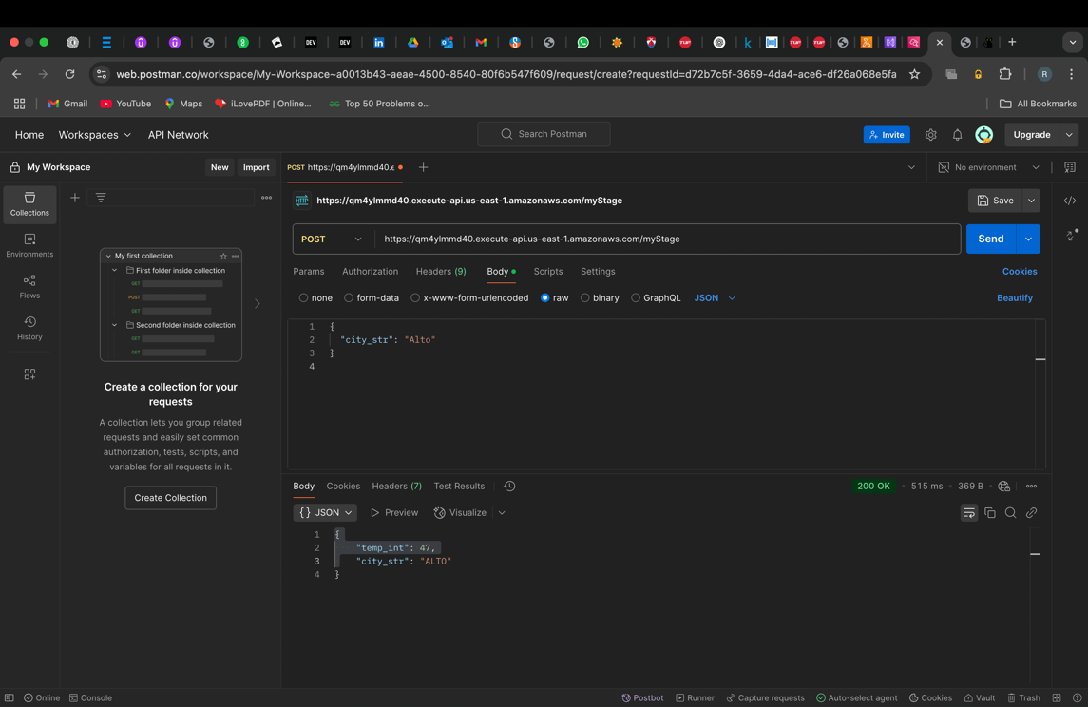

Checking on cloudfront

